**Project Structure**

|  |  |
| --- | --- |
| Date | 30 Oct 2022 |
| Team ID | PNT2022TMID36960 |
| Project Name | Virtual Eye - Life Guard For Swimming Pools To Detect Active Drowning |
| Maximum Marks | 4 Marks |

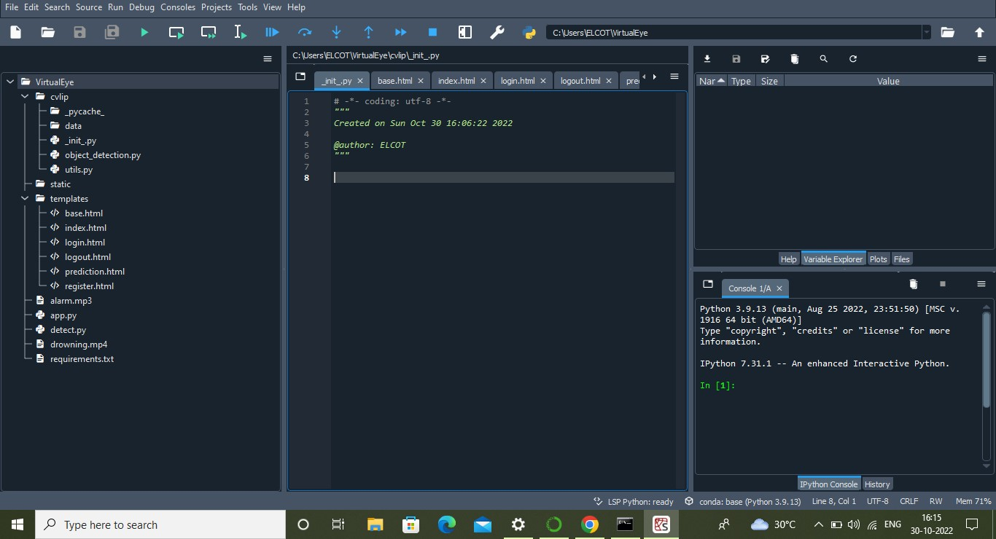

* The object_detection.py python file would detect the different objects such as persons, bicycles, cars, chairs, etc.
* The data folder contains the caffemodel (Caffe (Convolutional Architecture for Fast Feature Embedding) is a deep learning framework that allows users to create image classification and image segmentation, models. Initially, users create and save their models as plain text PROTOTXT files. After a user trains and refines their model using

Caffe, the program saves the user's trained model as a CAFFEMODEL file.)

* We are building a Flask Application that needs HTML pages stored in the templates folder and a python script app.py for server-side scripting
* The static folder has the CSS files which are necessary for styling the HTML page and for executing the actions.
* app.py contains the flask code which is used to detect the drowning person in a video input.
* Alarm sounds and demo videos are presented in project folders.